Week -8-DDCO Lab (Model-Simulator without test bench)
Lab program 3: Design Verilog HDL to implement simple circuits using structural , Data flow and Behavioural Model.
- Structural Model for AND Gate
module AND_2(output Y, input A, B);
and(Y, A, B);
endmodule

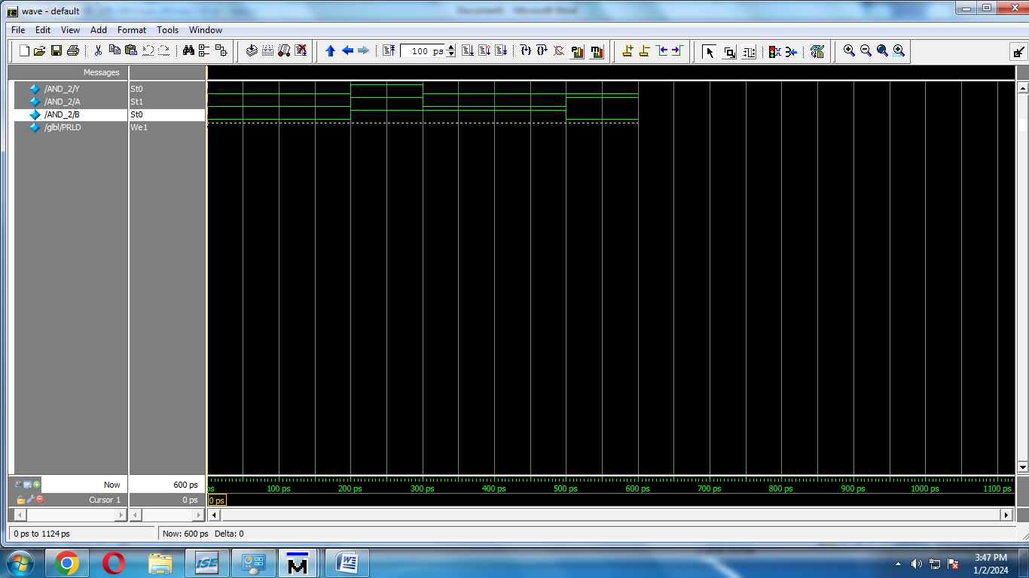

- Data Flow Model AND Gate

module AND_2(output Y, input A, B);
assign Y= A & B;
endmodule

OUTPUT
Case : a=0,b=0;
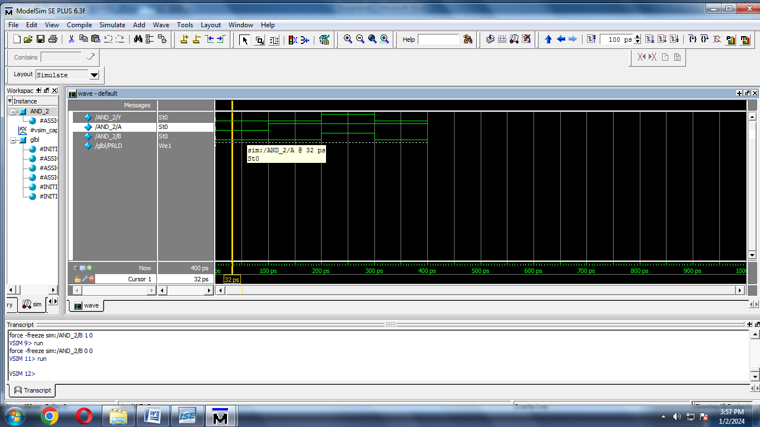
Case : a=0,b=1;

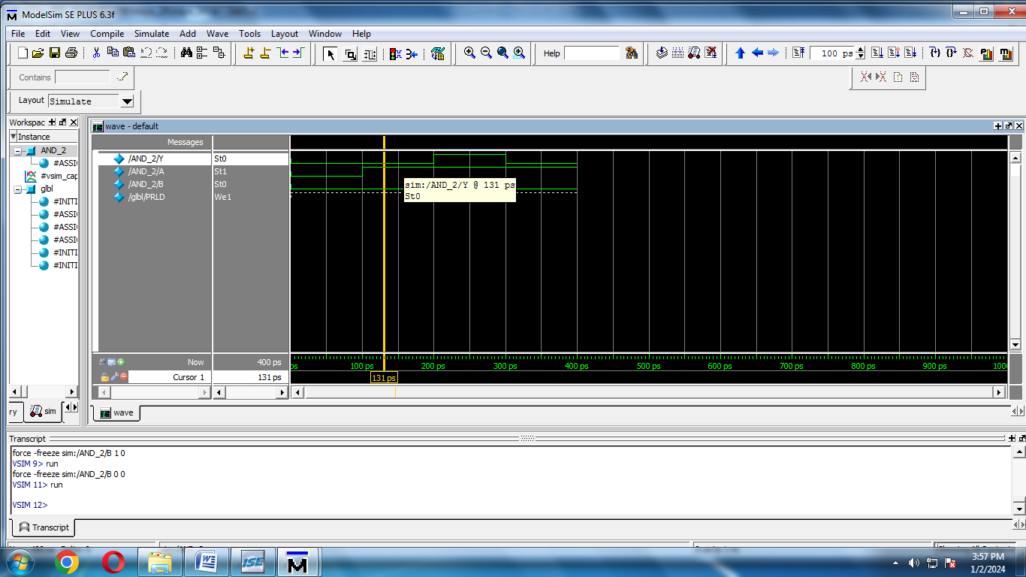
Case : a=1,b=1;

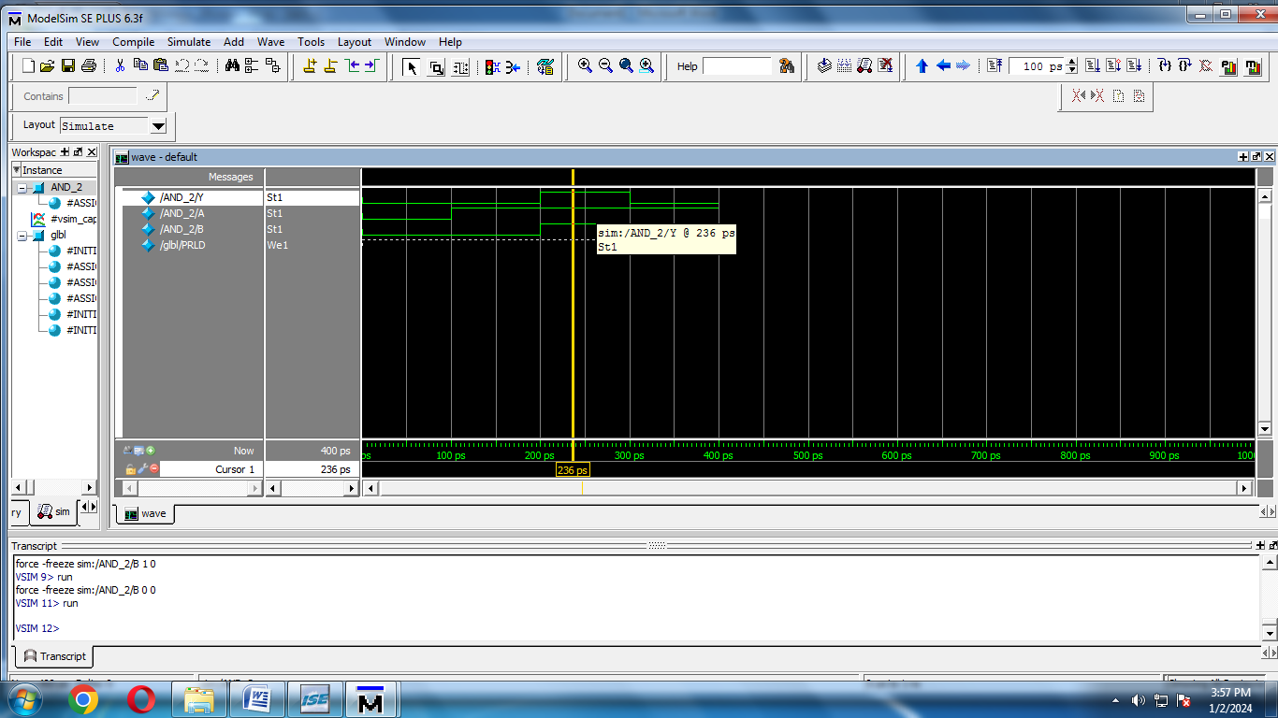

Case : a=1,b=0;

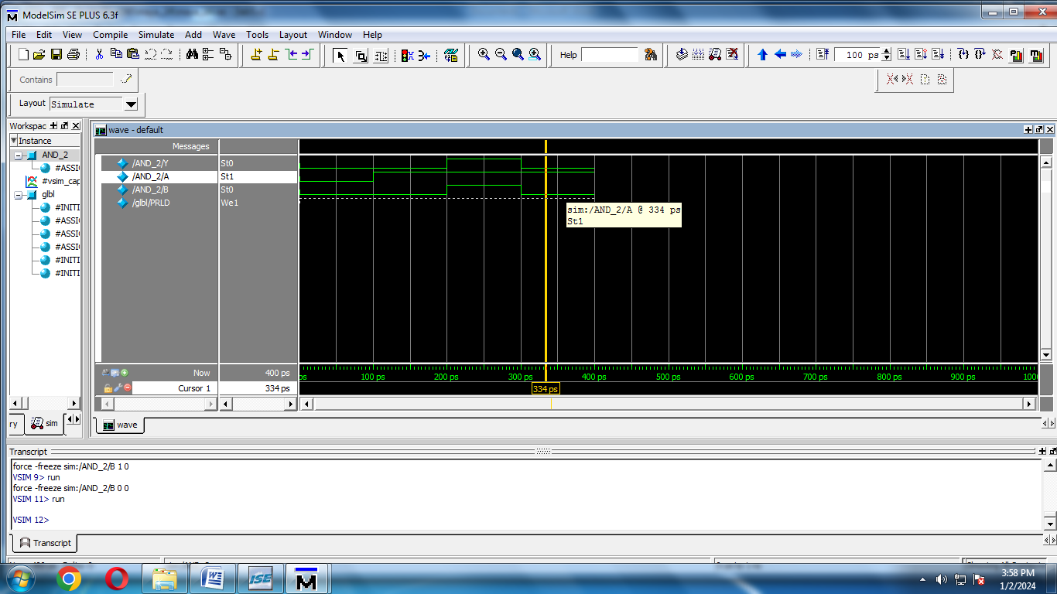

- Behavioural Model for AND Gate:
module AND_2(output reg Y, input A, B);
always @ (A or B) begin
if (A == 1'b1 & B == 1'b1)
begin
Y = 1'b1;
end
else
Y=1'b0;
end
endmodule

OUTPUT:

